Question: Currency Converter
You are provided with an incomplete HTML, CSS, and JavaScript setup for a Currency Converter project.
The goal is to complete the missing parts so that the converter works correctly and displays the converted amount properly.

Objectives
- Add an <option> tag with value="INR" and text Indian Rupees to the dropdown list of currencies.
- Display the converted amount as text inside the result paragraph.
- Change the background color of the Convert button to #00aaff.

Constraints
- Do not change the order of the currencies in the dropdown.
- Do not change the id or class attributes of any elements, as they are used by the JavaScript code.
- Ensure that the styling is applied correctly according to the provided CSS.

Expected Output
- The dropdown should include Indian Rupees (INR) as an additional currency option.
- When a conversion is performed, the converted amount should be displayed inside the result paragraph.
- The Convert button should appear with a background color of #00aaff.

Code:
<!DOCTYPE html>
<html lang="en">
<head>
<meta charset="UTF-8">
<meta name="viewport" content="width=device-width, initial-scale=1.0">
<title>Currency Converter</title>
<style>
body {
font-family: Arial, sans-serif;
background-color: #f5f5f5;
display: flex;
flex-direction: column;
align-items: center;
justify-content: center;
height: 100vh;
}

.converter {
background-color: white;
padding: 20px;
border-radius: 10px;
box-shadow: 0 0 10px rgba(0,0,0,0.1);
text-align: center;
}

h2 {
margin-bottom: 20px;
}

select, input {
padding: 8px;
margin: 10px;
}

#convertBtn {
padding: 10px 20px;
border: none;
color: white;
cursor: pointer;
/* TODO: Change the background color of the Convert button to #00aaff */
}

#result {
margin-top: 15px;
font-weight: bold;
}
</style>
</head>
<body>
<div class="converter">
<h2>Currency Converter</h2>
<input type="number" id="amount" placeholder="Enter amount">
<select id="currency">
<option value="USD">US Dollar</option>
<option value="EUR">Euro</option>
<!-- TODO: Add an option tag with value INR and text Indian Rupees to the dropdown -->
</select>
<br>
<button id="convertBtn">Convert</button>
<p id="result"></p>
</div>

<script>
document.getElementById("convertBtn").addEventListener("click", function() {
const amount = parseFloat(document.getElementById("amount").value);
const currency = document.getElementById("currency").value;
let convertedAmount;

if (isNaN(amount)) {
document.getElementById("result").innerText = "Please enter a valid amount.";
return;
}

if (currency === "USD") {
convertedAmount = amount * 1;
} else if (currency === "EUR") {
convertedAmount = amount * 0.9;
} else if (currency === "INR") {
convertedAmount = amount * 83;
}

// TODO: Show convertedAmount as text in the result paragraph
});
</script>
</body>
</html>

Existing output:
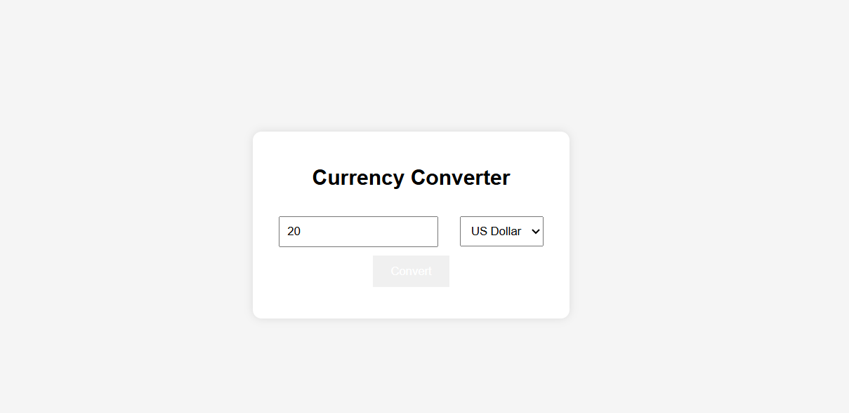
Excepted output:
